Labar Chithuen Non-wood forest product management and marketing Plan
KHAR GEWOG: PEMAGATSHEL
PLAN PERIOD: Sept 2021 – August 2026
First Revision

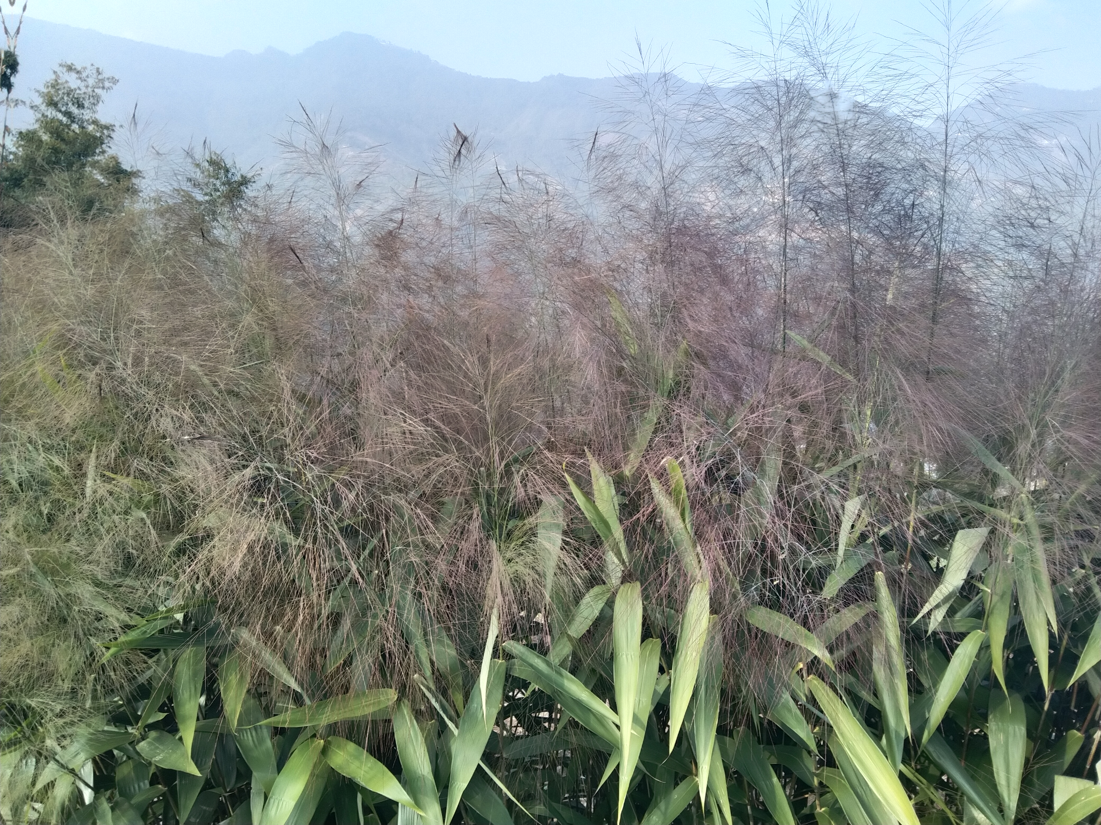
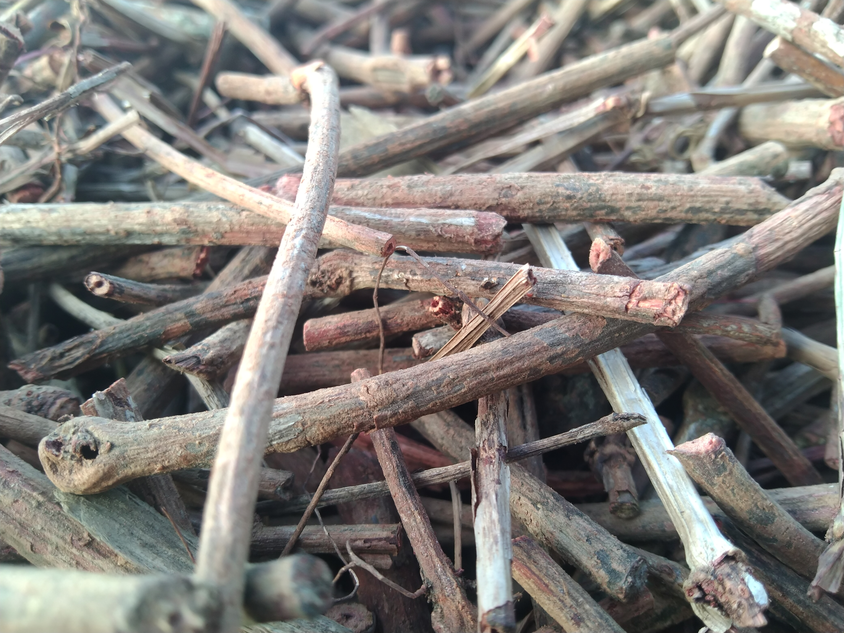
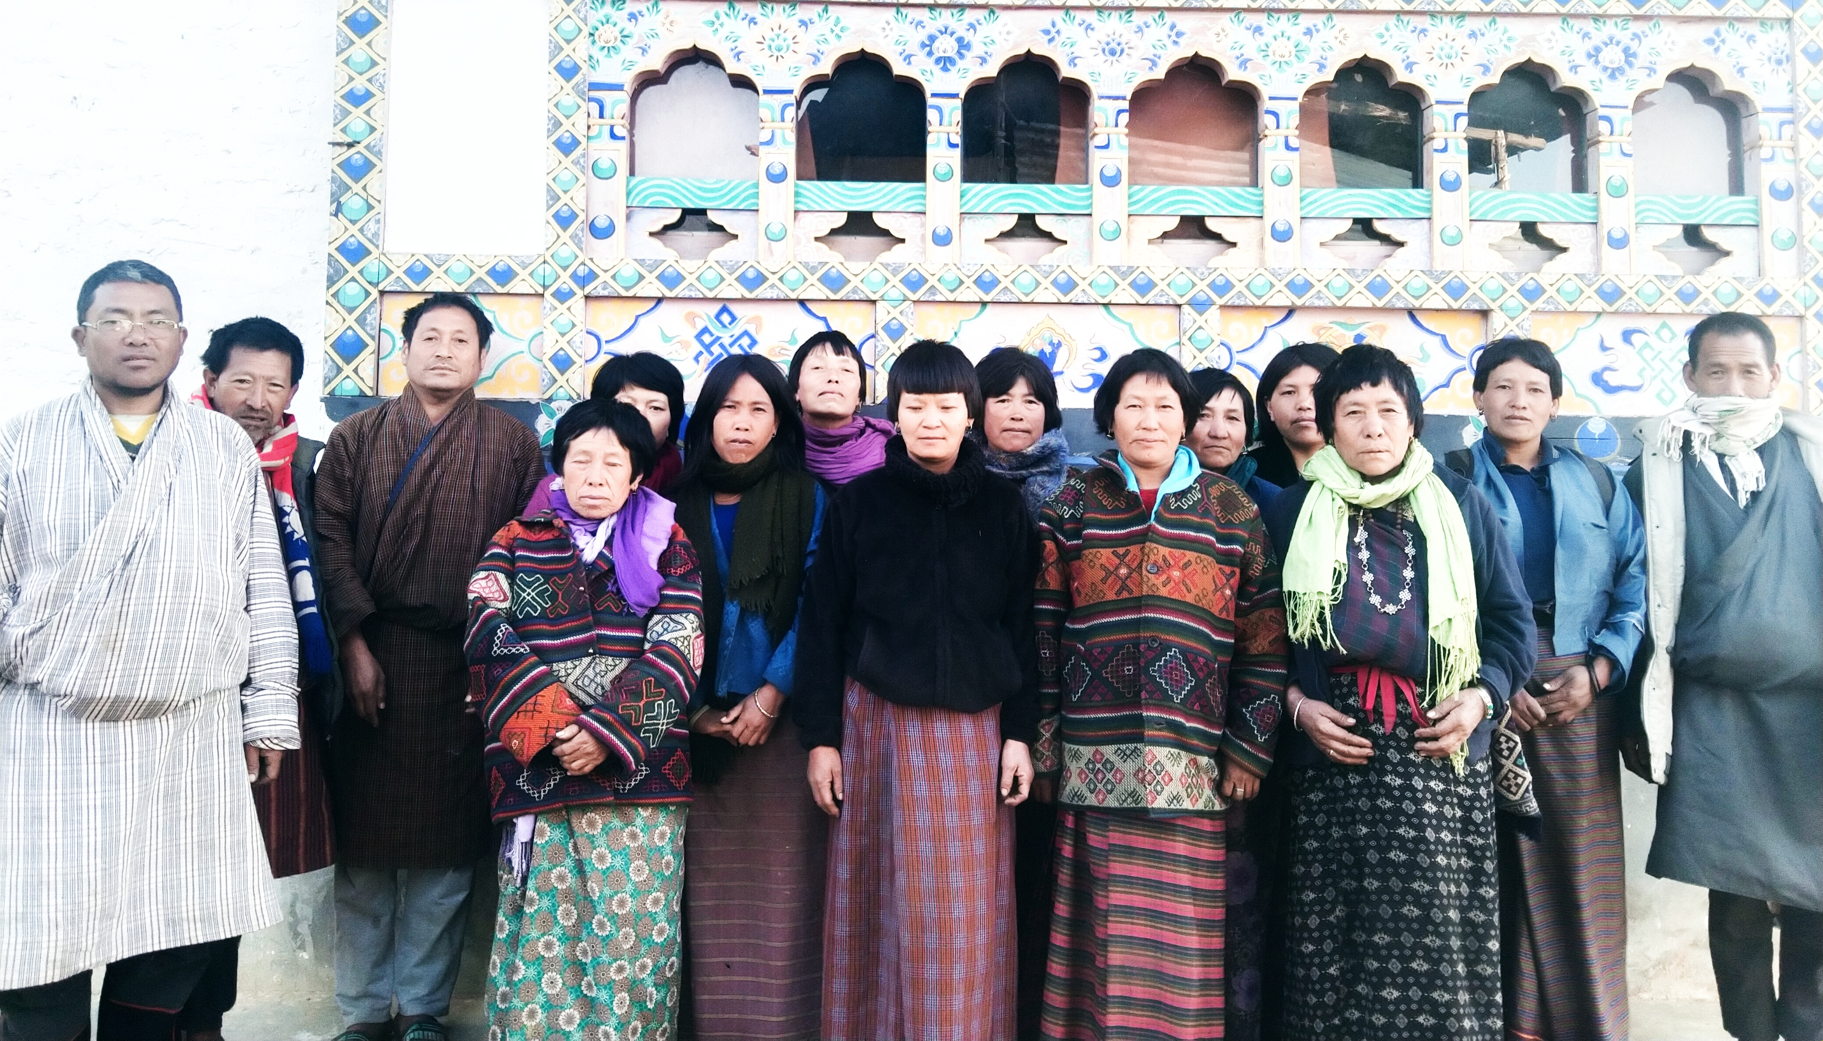
Table of content
PART I: Non wood Forest Products Management and Marketing Plan 3
1. BACKGROUND 3
2. The objectives of the management plan 4
3. Description on Non wood Forest Products and harvesting limit. 4
3.1: Short descriptions of Rubia cordifolia (Tshangla Kha: Laniru) 4
3.2: Short descriptions of Brooms Grass (Thysanolaena latifolia) 5
4. Harvesting prescriptions for sustainable NWFP harvesting 7
5. Map of the NWFPs collection area. 7
5.1 NWFP collection area demarcation in Google Map 7
5.2: Sketch map showing NWFP distribution in collection area 8
6. Marketing and sales plan 8
7. Benefits to the members 9
8. Benefits to the group 9
PART II: BY-LAWS-GROUP REGULATIONS AND NORMS 10
9. Procedures for new membership 10
10. Procedures for leaving the membership 10
11. Responsibilities and rights of members 10
12. Executive committee and their responsibilities 10
12.1: Roles and Responsibilities of Chairman 10
12.2: Roles and Responsibilities of Secretary 11
12.3: Roles and Responsibilities of Treasurer 11
13. Tenure and benefits for executive committee 11
14. Community Development Fund and utilization of fund 12
15. Conflict resolution 12
16. Fines and Penalties 12
17. Meetings 13
18. Amendment of the group’s by-laws 13
19. Member list 14

GLOSSARY AND ABBREVIATIONS
CDF Community Development Fund
CFO Chief Forest Officer
SFED Social Forestry and Extension Division
SRFL State Reserved Forest Land
DoFPS Department of Forests and Park Services
DT Dzongkhag Tshogdue
GRO Gewog Range Officer
HHs Households
NWFPs Non-Wood Forest Products
ToR Terms of Reference

PART I: Non wood Forest Products Management and Marketing Plan

1. BACKGROUND
Labar Chithuen Non- Wood Forest Products (NWFP) Management Group comprised of 20 households from Labar village under Khar Gewog. Out of 26 households in the village only 20 households had shown willingness to be registered as NWFP management and marketing group members. The villager has access to different types of NWFP products such as Plectocomia Himalayana (Patsha), Rubia cordifolia and Pouzolzia spp and Thysanalaena latifolia. However, most of these species are found sporadically distributed in adjacent community forest and can meet only local household demand. During the earlier plan period, the group collected mainly Rubia cordifolia. The collection of other species was limited due to distribution nature and quantity available for harvest in the forest.
Although during the earlier plan period the group collected only Rubia cordifolia but in this plan period, members want to collect the Thysanalaena latifolia (Brooms) to make income. It is found growing in their fallow privately registered land and in the State Reserved Forest Land where canopy density is not that closed. Also the group members expressed that regeneration of Rubia is also good in young forest and abandoned fallow agricultural lands. Therefore, creation of opening and shrub forest is must for sustainable harvesting of Rubia cordifolia both NWFPs species identified for collection.
The Management plan consist of two parts: The Part I descriptions on Non wood Forest Products Management and Marketing aspect and Part II on group’s by-laws. The By-law are prepared to outline group governance, roles and responsibility of executive committee and fines and penalties to ensure successful implementation of group activity.
The term of management plan is for 5 years and will be effective from September 2021 to August 2026. During the period, the members will have right to collect mentioned NWFPs within demarcated boundary as per the harvesting guidelines prescribed in the plan and also ensure sustainability of resources in the future.

2. The objectives of the management plan
- Harvest nearby NWFP resources through sustainable management.
- Ensure equitable benefits sharing with prescribed management plan.
- Income generation through sale of NWFP products.

3. Description on Non wood Forest Products and harvesting limit.
The group will manage and collect two species of Non wood Forest product. These are Rubia cordifolia and Thysanolaena latifolia. The brief description of each species is made are hereunder. Further, to ensure sustainable management of resources annual harvesting limits are set and presented in table 01.

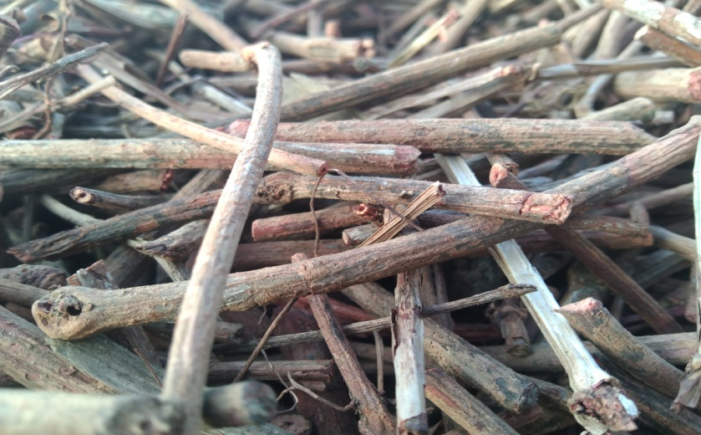
3.1: Short descriptions of Rubia cordifolia (Tshangla Kha: Laniru)
Photo 01: Dry pieces of Rubia cordyfolia

Rubia cordifolia is climbing or creeping perennial herb with stem up to 10 cm long, with woody, long, cylindrical, flexuous roots with thin red bark; stem branched, with long internodes.
The species has wide ecological adaptability. It is found in forest edges and clearing, shrub vegetation and dune forest. In the village, the species was found distributed throughout the villages thereby making easy and accessible for farmers to harvest. The roots and stem are harvested exclusively from the wild and from their private land by the farmers and exported as one of the source of income for their livelihood.
Uses
The species is dye-producing plant which is harvested for processing dyes. The species is also known for medicinal values. It is used for treating wounds or cuts to stop bleeding as an antiseptic. The roots are used to as an emetic in case of stomach problems, to treat inflammation of the mammary glands in cattle and to cure itchy skin in human.

3.2: Short descriptions of Brooms Grass (Thysanolaena latifolia)
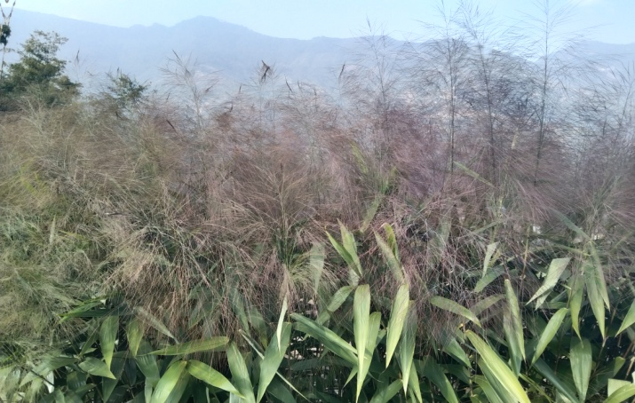
Photo 02: Thysanoleona latifolia with matured panicles

Thysanolaena latifolia (locally called Tsakusha) is found growing around the peripheral of their private registered land. The species grows as high as 2.5 meters and is mostly found in open areas particularly at the edges of mortable road, in sloppy areas and ravines. The leaves are linear, about 5 cm wide and 30 cm long; and are alternately arranged at an interval of 12.5 cm. The panicles which are the main material for soft-broom production has an average length of 50 cm while its stalk measures about 70 cm long. It can be grown in many types of soils such as clay, sandy clay loam and sandy loam. A one and one-half year old broom grass starts producing panicles that develop from October to March every year. The community of the Labar started growing species in and around their registered land for land stabilization and for soft brooms.

Uses
Globally it is planted to control soil erosion and as agro forestry crop in many countries. It also used as live fencing and boundary plantations materials. However, in Laber village people plant it to harvest panicles for making soft brooms. The leaf of the plant is also good forage for animals like cattle and horses.
Table 1: Block description of individual NWFPs species
NWFP name | Name of Collection area | Parts harvested | Use purpose (traditional and others) | Harvesting season (months) | Annual quantity collection
Rubia cordifolia  (Laniru) | Dungphu, Yarpangthang, Langzor Nakpoladrang, Maksamri, and Labar Village. | Mainly the stem | Dyes | December - February | 1500 Kgs in a year
Tsakusha (Thysanolaena latifolia | Labar, Nakpoladrang, | Use upper parts of inflorescence | Fodder, soft broom | December-April | 50 bundles

4. Harvesting prescriptions for sustainable NWFP harvesting
Table 2: Harvesting prescriptions for sustainable NWFP harvesting
NWFP species | Harvesting prescriptions for sustainable harvesting
Rubia cordifolia (Laniru) | - Cut the stem maintaining about 2 inch above the ground without damaging the roots system using sharp knife or sickle.  - Do not uproot rhizome  - Maintain about 10% of total population in the particular collection site for regeneration in the following years.  - Collect after shading leaves and time specified in the plan.
Thysanolaena latifolia  (Tsakusha) | - Cut the foliage, inflorescence at 15 cm from the ground.  - Do not damage the rhizomes.

5. Map of the NWFPs collection area.

5.1 NWFP collection area demarcation in Google Map
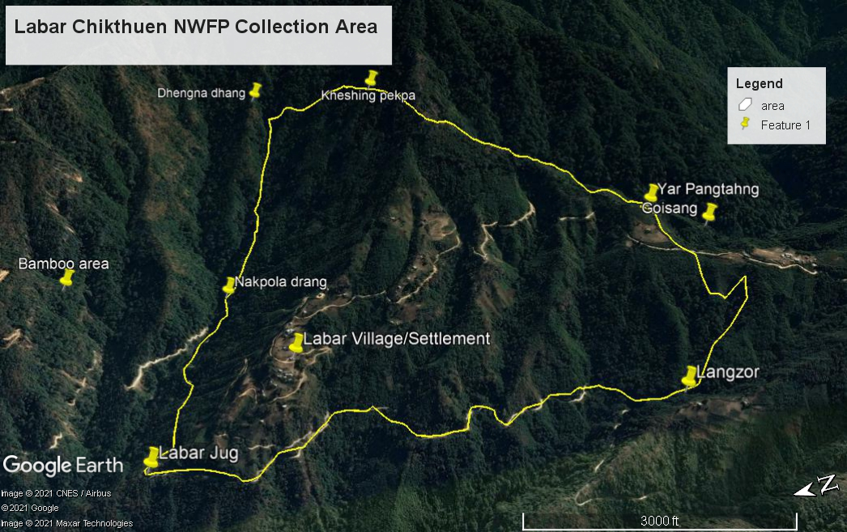

5.2: Sketch map showing NWFP distribution in collection area
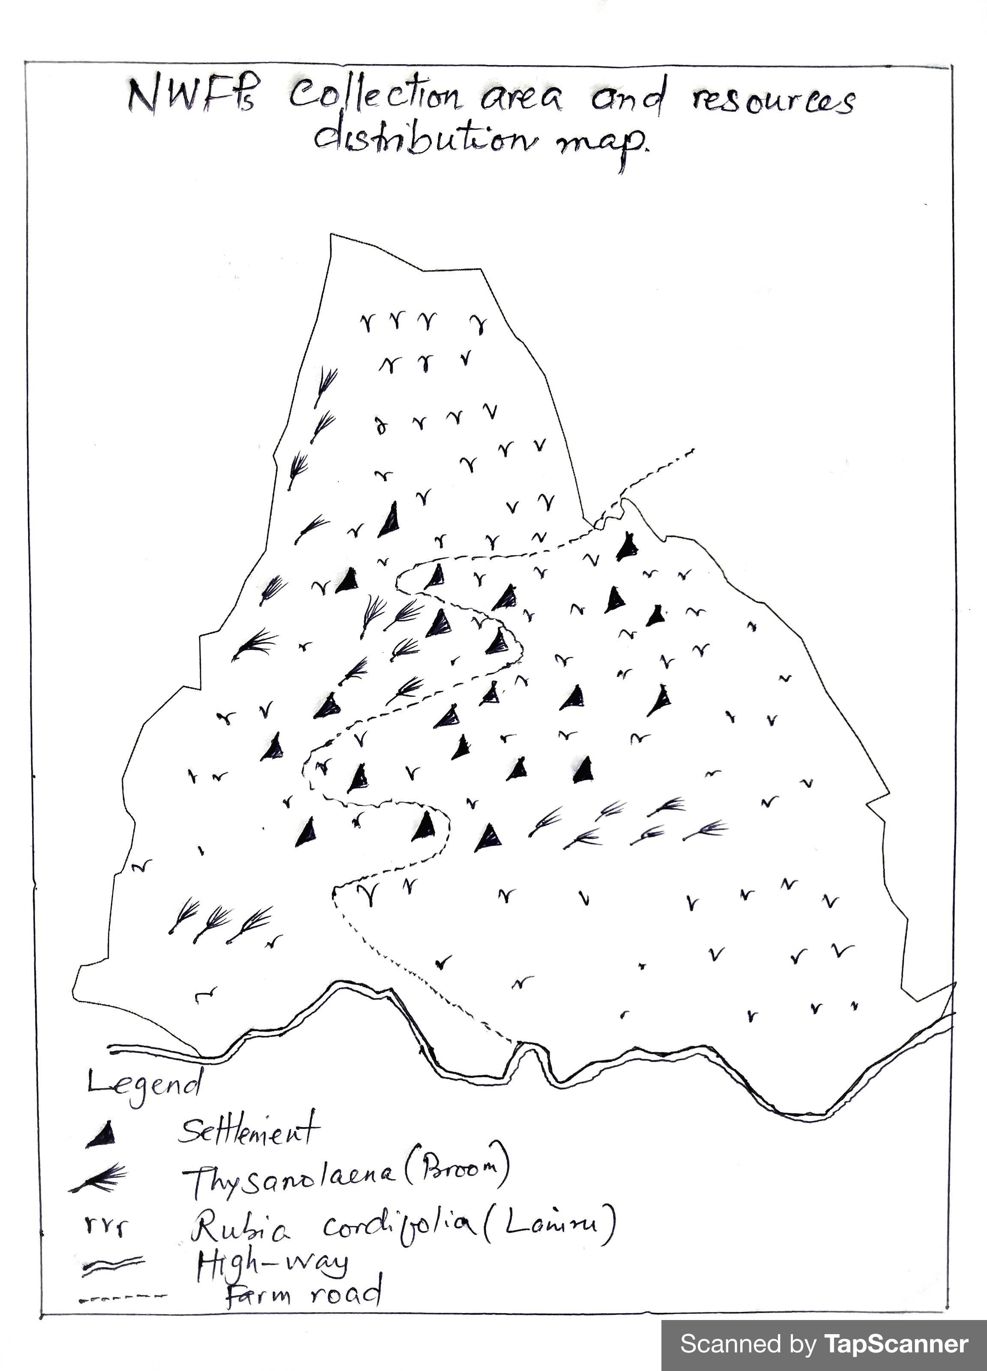

6. Marketing and sales plan
Table 3: Marketing and sales plan of NWFPs
NWFP name | Potential market | Estimated quantity for sale per season | Expected price per unit (Nu) | Total  (Nu.)
Rubia cordifoia (Laniru) | Local trader and Licensed Exporter | 1500 Kgs | 60 | 90000
(Thysanolaena latifolia (Tsakusha) | Local trader, local market, and vegetable vendors | 50 bundles | 50 | 2500
Total |  |  |  | 92500.00

6.1: Marketing arrangements
The members will collect the NWFPs individually, dry them and store properly. The executive committee members will collect the NWFPs product to the auction yard and inform to the concern forestry official/DAMC. The concern forestry official/DAMC will then organize NWFPs auction to various NWFPs traders. The auction will be organized in the presence of Chairman from the respective NWFPs group representing the members.
The executive members may deduct the expenditure such as transportation, necessary deduction and compensation prior to the payment to the individual member. The sharing of income to the individual group member will be done based on the quantity of NWPs collected by the respective members after deduction of all necessary expenditure.

7. Benefits to the members
With this group formation the individual member have equal opportunities and access to resources. The income earned from sale of NWFPs will enable members to buy households basic necessities like buying of salt, rice, sugar and oil. Additionally, the sale of NWFPs will benefits school going children to meet their expenses.

8. Benefits to the group
The group will be able to collect the various NWFP products legally and sustainably as prescribed by the management plan. Through this, the group can support to disadvantage individual members from community fund. Most importantly, being the part of a group helps the community in fostering the community bonds for betterment of the society and rural livelihood.

PART II: BY-LAWS-GROUP REGULATIONS AND NORMS
Name of NWFP Group: Labar Chithuen NWFP Management and Marketing Group
Total Membership: 20 Households

9. Procedures for new membership
- Membership fee of Nu. 100/- shall be collected annually by treasurer.
- The new membership shall be allowed for the family members with Thram and census registered in the village with verification by executive committee and approval from members. However, he/she should be willing to pay 70% individual share eligible from accrued fund.

10. Procedures for leaving the membership
- Any members withdrawing from the group without interest will be allowed without any benefits from the group.
- A childless members retiring from the group due to old age shall be entitled to get his/her divided share from joint account (CDF).

11. Responsibilities and rights of members
- The group members participating in this management of NWFP will have equal rights and responsibilities for controlling, protection, management and harvesting in the identified collection areas.
- The individual members will have the equal rights to collect and harvest as per prescribed management plan.
- Every member of the group will have right to report to the committee members for violation of the management rules.
- The members should agree on collection and sale of NWFP products.

12. Executive committee and their responsibilities

12.1: Roles and Responsibilities of Chairman
Chairperson: Mr. Lekzang Dorji (Contact #: 17819250)
- To chair all kinds of meeting related to NWFPs management, collection and marketing.
- To resolves the disputes and conflict arising among the members.
- To enforce the fine and penalty.
- To explore market for the products.
- Fix date of collection and inform members accordingly.
- Maintain contacts with traders, to arrange & coordinate marketing of NWFPs.
- Cosignatory for withdrawal of fund from the bank.

12.2: Roles and Responsibilities of Secretary
Secretary: Mr. Sangay Dorji (Contact #: 17673848)
- Provide assistance to the Chairman.
- Officiate as Chairperson during his absence.
- Maintain records of the activities implemented, and also minutes of meeting.
- Responsible for writing official correspondence.
- Compile the progress report and submit to the Gewog Range Officer.
- Cosignatory for withdrawal of fund from the bank.

12.3: Roles and Responsibilities of Treasurer
Treasurer: Mr. Kinzang Wangdi (Contact #: 17586616)
- To maintain detail financial record and present the details funds to Committee and the group members when necessary.
- Officiate as Chairperson or Secretary in their absence.
- Maintain the cash transaction record, submit expenditure and cash balance report to Chairman and present it to the members during meetings.
- Facilitate collection of membership fee from the group members.
- Deposit and as well withdraw money from bank for implantation of group activities.

13. Tenure and benefits for executive committee
- The tenure of service for the committee members is for 5 years.
- Anyone representing the NWFP group and attends meetings/important gatherings will be provided with transportation charges prior on recommendation and verification done by Gewog Range Officer. For this, the individual shall produce following documents dually verified by the Gewog Range Officer.
- Vehicle number and vehicle type
- Name and CID number of Driver
- Total expenditure incurred/Bills/ cash memo
- Executive committee will be paid Nu.1000/- annually as service charges from the group fund.

14. Community Development Fund and utilization of fund
- The source of community development fund will be from sale of NWFPs products, membership fees and fine and penalties. It will be deposited in Bank. Additionally a fund will also be raised from collection of sale proceeds.
- All expenditure incurred for the benefit of the group will be beard from the joint Account.
- Technical support will be sought from the concerned Gewog Forest Range Officer.

15. Conflict resolution
The issues/conflict related to NWFP will be resolved by NWFP chairman and executive committee based on their capacities. The unsolved conflict will be forwarded to the Gewog Administration through Chairman. If it cannot be solved at Gewog level, it will be forwarded to Divisional Forest Office for necessary action.

16. Fines and Penalties
Sl No | Activity/Particular | Procedures | Penalties
1 | Meetings/ Labour contribution | Members to cooperate the Executive committee for any NWFP management work and important meeting. | 1st absentee: Nu. 200/-
 |  |  | 2nd absentee: Nu.200/-
 |  |  | 3rd absentee: Expelled from the membership upon unanimous decision of the members.
2 | Collection of NWFP Period (No collection of NWFPs will be entertained beyond prescribed period) | Dec - Feb | Product will be seized and offender will be fined Nu.2000/- per occasion.
3 | Number of collector per Household | One/HH | Product will be seized from one of the individual and will be fined Nu.2000/- per head.
4 | Collection site will be within designated boundary. No land owner shall have right to claim the ownership of NWFPs. | Registered land and State Reserved Forest Land. | If private land owner restrict the collection of NWFP claiming the ownership, the owner shall pay the fine of Nu.215/- to all the registered members.
5 | Non-members collecting the NWFP in their NWFP area. | No Non-members will be permitted to collect the NWFPs. | The products will be seized and will be fined as per the FNCRR-2017.
6 | Deployment of Non-member during harvesting of NWFPs. | No deployment of labor will be entertained as a replacement to collect the NWFPs. | The product shall be seized and fined Nu.2000/- per head count.
7 | Sale of products without approval and idea of executive committee. | Sale of product to be through open auction | The offender shall be terminated from membership permanently.

17. Meetings
The meeting will be conducted during collection of NWFPs, after collection of the products and during sale of products and as when necessary. The secretary will maintain the minutes of the meeting.

18. Amendment of the group’s by-laws
The by-laws will be amended based on the needs to resolve issues pertaining to group functions. However, it will be made only with consultation with Gewog Range Officer with approval from Divisional Forest Office, Pemagatshel.

19. Member list
